**EQBD**

**Equip to build**

Our company is a local family business which specializes in the supply of infrastructural based machinery to the highest quality and trustworthy market prices. With over 10 years of experience and awards in giving the best services to our customers, we guarantee safe and quick deliveries to wherever you are in the world on the calculated time and we take full responsibility in terms of delays or damages.

Credibility

Our supply products are credible enough as we ensure that our personal company engineers follow up the manufacturing processes to the core and monitor all works till the its time for the products to be released on the market. The process steps are as follows:

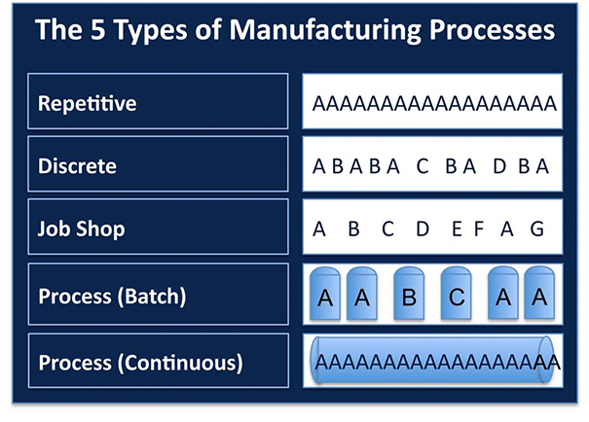

Our Machinery

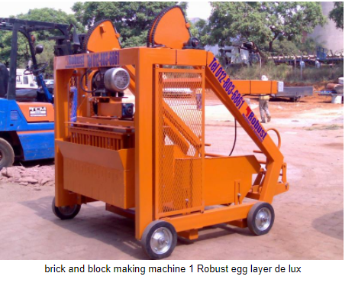Measurements are as follows:

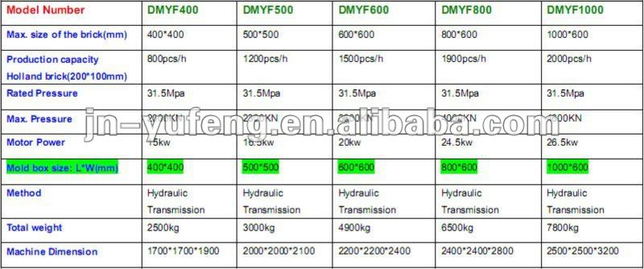

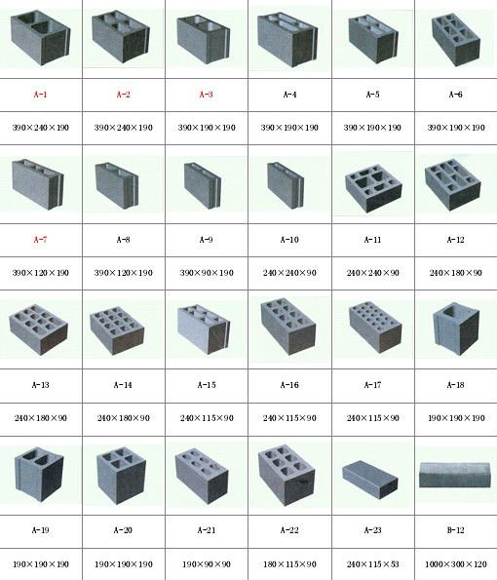

In the picture we have the fast and effective brick and block machine Robust one de lux layer, which one is one of our most purchased products.

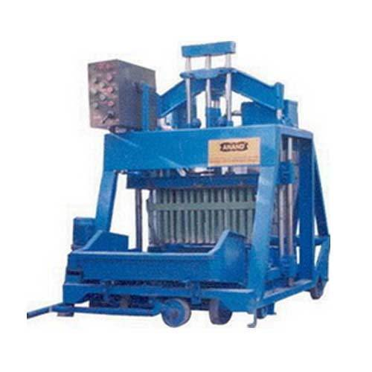

We also have it in blue, green and yellow all readily available and non-fade colors. The size of the machine is basically based on what you want just inform us and will play our part, we have ranges from the biggest imaginable side to the smallest imaginable size to the highest quality. Feel free to visit our exhibition on the 19th of April and witness true power and quality made bricks to strengthen your future infrastructure to the highest ordeal.

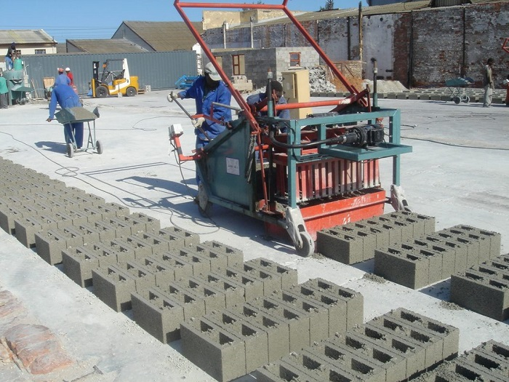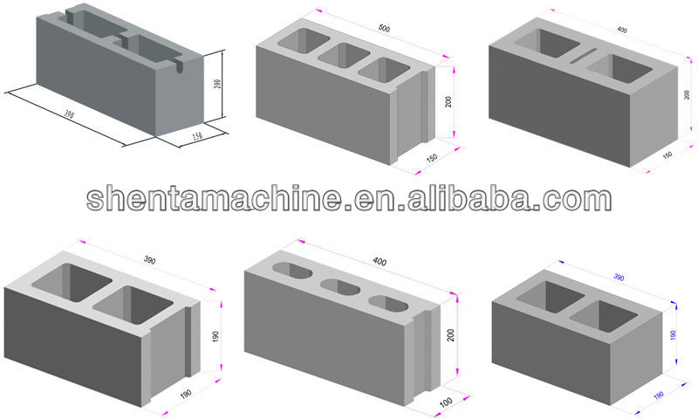

The brick and block machine Robust in action in South Africa, it can be used for small and big projects due to its efficiency.

Transportation and Insurance

Our insurance company of whom we have worked with for many years covers and bares all transport related commodities, once the purchase is done locally our insurance company will see to it that the product is driven to you instantly from the moment of purchase through the use of our company trucks and security armored vehicles for transportation.

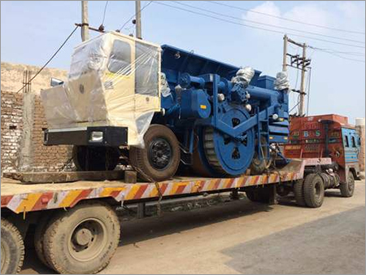

If the purchase is international your product will be sent to the insurance company’s loading dock immediately after purchase and will be transported to the owner by ship all under two months

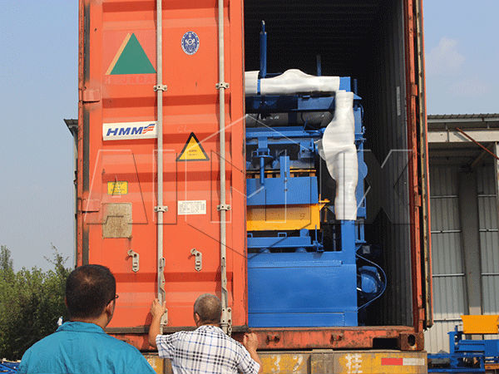



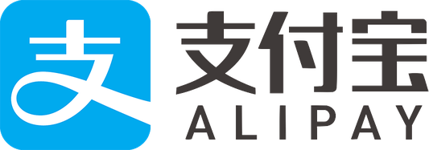 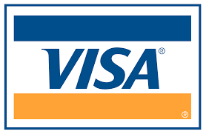

 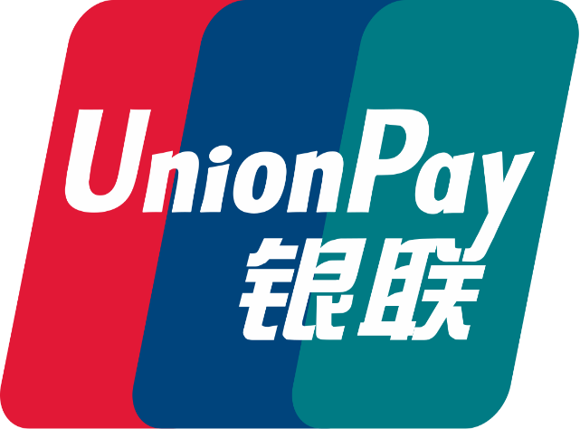

All these modes of payment are accepted and during holidays come with massive discounts and bonuses on big purchases.

Address: MOBILE: 0824538651

316 MUNDT STR TEL: 0128036861

PRETORIA, SOUTH AFRCA

***Our customer care service hotline is 111 with responsive delightful service providing to meet the customers utmost needs regardless how small or huge.***

***Let’s get building! Thank you.***